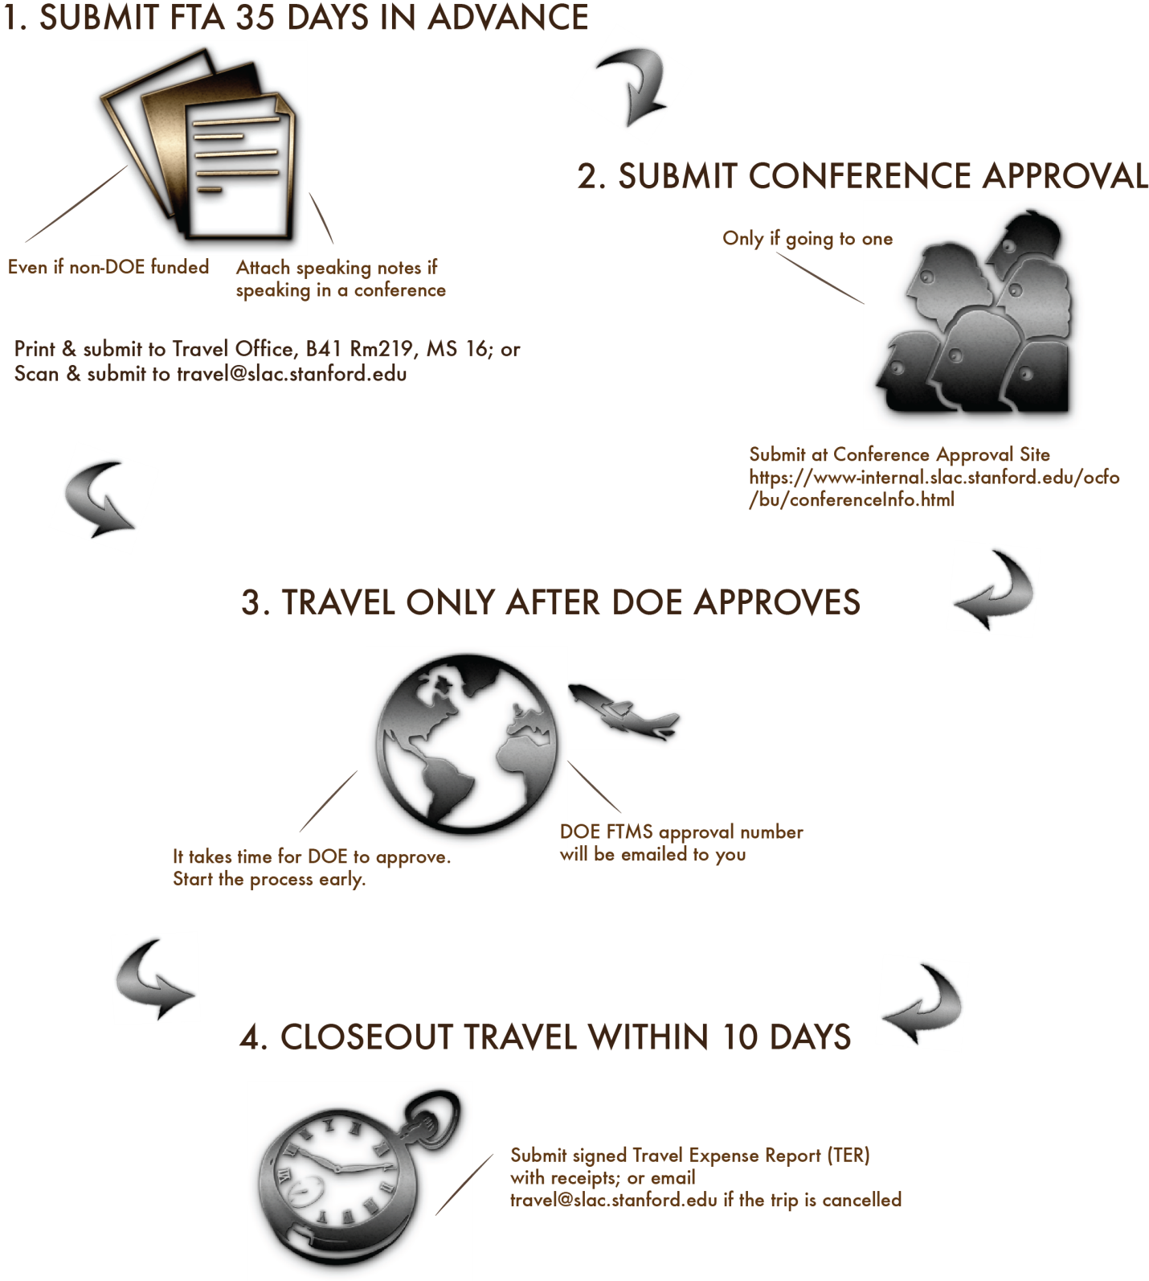

This form is used to collect data necessary to support the DOE Foreign Travel Management System (FTMS). Items marked with * must be completed.

Travel Office Use Only
FTMS# | Ecc# | SAFE Required? | Travel Dates:
Presentation Notes/Abstract/Agenda Foreign Funded Airfare Comparison Personal Travel
Notes:

Section I. – Traveler Information (To be completed by traveler)
1. *Last Name | *First Name |  |  | *Middle Name or NMN
ONLY fill items 2-14 if this is your first SLAC foreign travel or if any data needs updating in FTMS
2. *Last 4 Digits of SSN (if available) :
3. *Passport Number | 4. *Passport Country |  |  | 5.*Expiration Date (mm/dd/yyyy)
6. *Gender  Male Female |  | 7. Permanent Resident Green Card Holder?  Yes No
8. *Birth Place Country |  | 9. *Citizenship
10. Employment Address: SLAC or
*Street Address
*City *State *Zip
11. Contact Information

*Work Phone:
Work Fax:
Home Phone:
International Cell Phone:
Domestic Cell Phone:
*E-mail Address:
12. Travel Administrator’s Email Address (to get copied on trip approvals):

13. *Position/Title
14. *Indicate whether you have held a DOE security clearance
Yes No If yes, indicate the highest level received

Section II - General Trip Information
Use additional general trip information pages as required and include all funding types estimated for this trip request.

15. *Place of Departure (City, State, Country) | 16. *Departure Date: Click here to enter a date.
 | 17. *Return Date: Click here to enter a date.

18. *Estimated travel costs by funding type
Primary  Sponsor | Funding Type | Charge Number |  | Estimated Airfare | Estimated Other
Yes
Yes
Yes
19. Type of Travel: |  |  | 20. If not coach, give justification for premium travel:
21. Names and Organizations of other personnel accompanying the traveler as a team

22. *Benefit to Government (include benefit to present position and the department)

23. Comments:

24. *Has the traveler contacted his/her Medical Support Staff to ensure awareness of safety & health issues of the country(ies) to be visited? Yes No
25. Will the traveler be taking DOE or laboratory owned equipment on this travel? Yes No

Section III – Trip Itinerary
Account for the entire timeframe between departure and return by completing a separate itinerary for each city/country to be visited (for the exception of personal leave).

26a. *Is this part of the trip associated with a conference? Yes No Unknown
If yes, submit conference attendance form(s) 90 days before start date and complete item 26b
26b. Complete this section if attending a conference (if presenting, please include draft of notes and agendas)
Conference Name:
Conference Start Date: Click here to enter a date. Conference End Date: Click here to enter a date.
URL:
27. *Destination City, Country: |  |  | 28. *Start Date: Click here to enter a date.
 |  |  | 29. *End Date: Click here to enter a date.
30. *Select One or More Primary Purpose(s)  Professional conference or workshop  Seminar/Symposium  Working group or colloquia (scientific meeting)  Site Visit  Research & Development activities under an informal, lab-to-lab, or government agreement |  |  | Meeting(s) on scientific, technical, project or programmatic matters  Procurement-related matters  Official Stop Over  Permanent Change of Station  Other(s):
Personal Leave Start Date Click here to enter a date. End Date: Location:
31. *Justify Trip Purpose (i.e. Topics to be discussed, formal presentation or paper)

This part of the trip involves:  *32. Lab-to-Lab agreement? Yes No  *33. University-to-Lab agreement? Yes No  *34. International agreement? Yes No  If yes, enter agreement:  *35. Will classified information be discussed? Yes No  *36. Is the traveler planning on interacting with anyone  from a DOE-designated sensitive country? Yes No  *37. Does this Itinerary involve Training? Yes No  *38. Will any part of the trip discuss sensitive subjects?  Yes No |  |  |  |  | *39. Will any part of the trip discuss sensitive subjects as defined by DOE’s Sensitive Subject List? Yes No  *40. Will any part of the trip involve information that is subject to US Export Control restriction? Yes No  *41. Meeting with senior government official(s)? (for non-DOE employees) Yes No  i. Please provide official’s name, position, and contact information. Describe meeting goals:  *42. Embassy assistance will be required? Yes No  If yes, please describe.
43. Contacts
*Host Name | *Host Phone | *Affiliated Institution |  |  |  | *Facility to be visited | *Date Visited
*Hotel/Lodging Name |  |  |  | *Hotel/Lodging Phone
44. Emergency next-of-kin Contact (*for travel to Germany & Switzerland)
Name: Telephone Number:
Click for additional Section III

Late Foreign Travel Approval Waiver (if submitting less than 35 days)
*Please explain why this is submitted after the deadline:

Reviews and Approvals
I. *Traveler
Name (Type or Printed):
Title:
Organization:
Signature ____________________________________ Date ______________________
Comments:
II. *Supervisor Approval
Name (Type or Printed):
Title:
Organization:
Signature ____________________________________ Date ______________________
Comments:
III. *Business Manager/Planner (per AID Matrix) Approval
Name (Type or Printed):
Title:
Organization:
Signature ____________________________________ Date ______________________
Comments:
IV. Optional Approval for Directorate Use Only
Name (Type or Printed):
Title:
Organization:
Signature ____________________________________ Date ______________________
Comments:

